Exercise 4

Given circuit 4, Calculate V0(t) for t > 0. Plot Vc(t) versus time using MATLAB and include the plot in your report. Now simulate this circuit using MultiSim and plot V0(t) versus time.

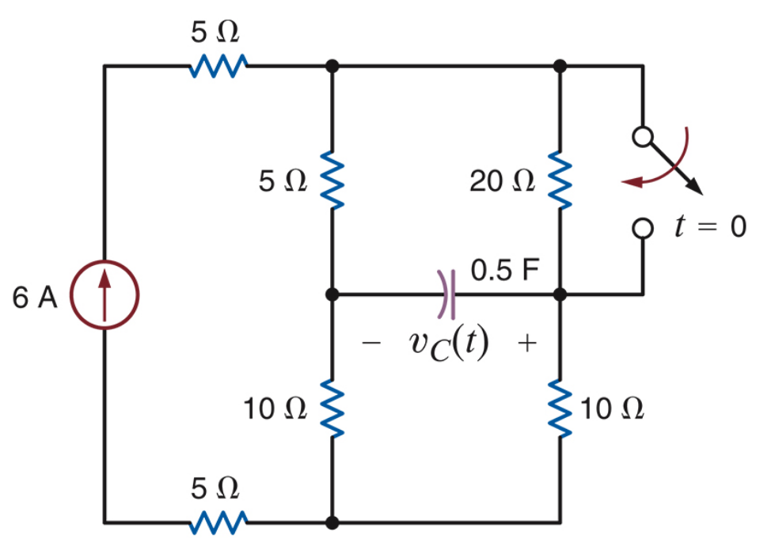

Circuit 4 for exercise 4

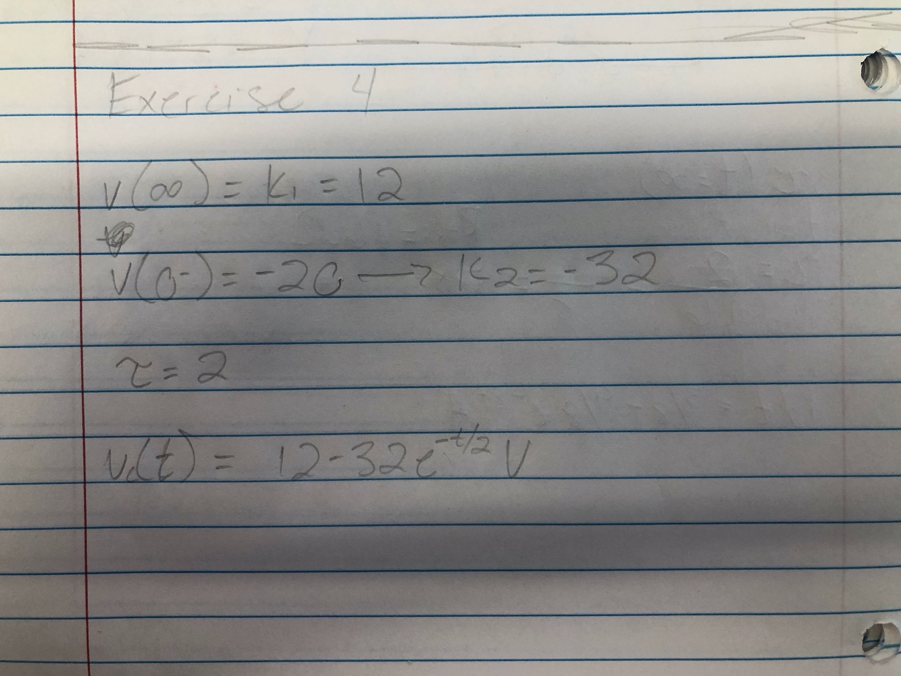

Equations for exercise 4

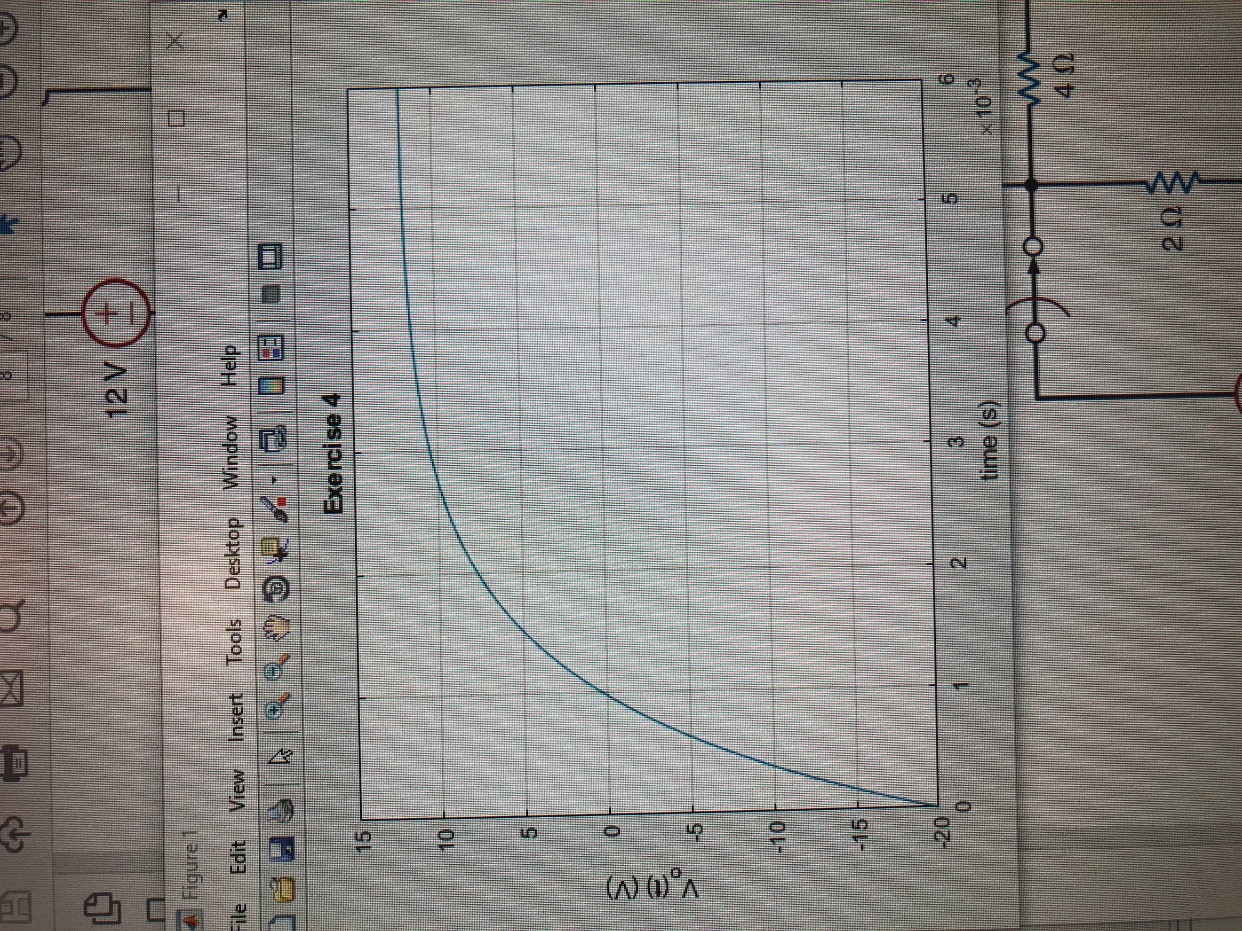

MATLAB plot

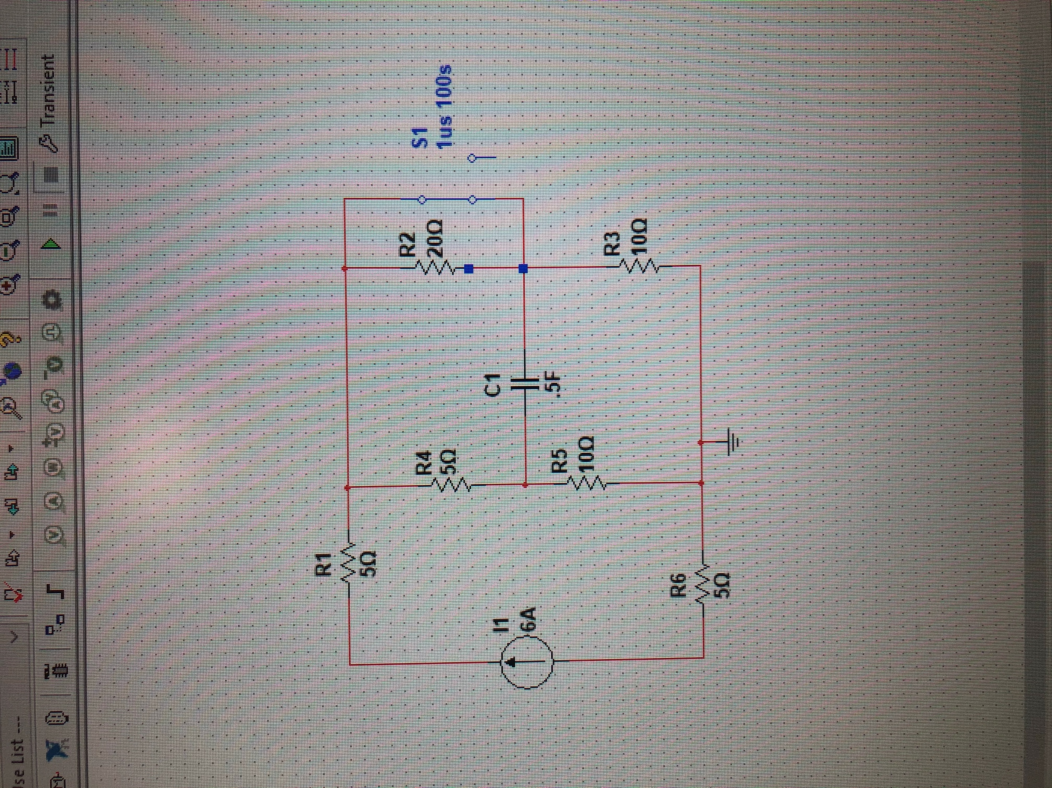

Schematic for circuit 4

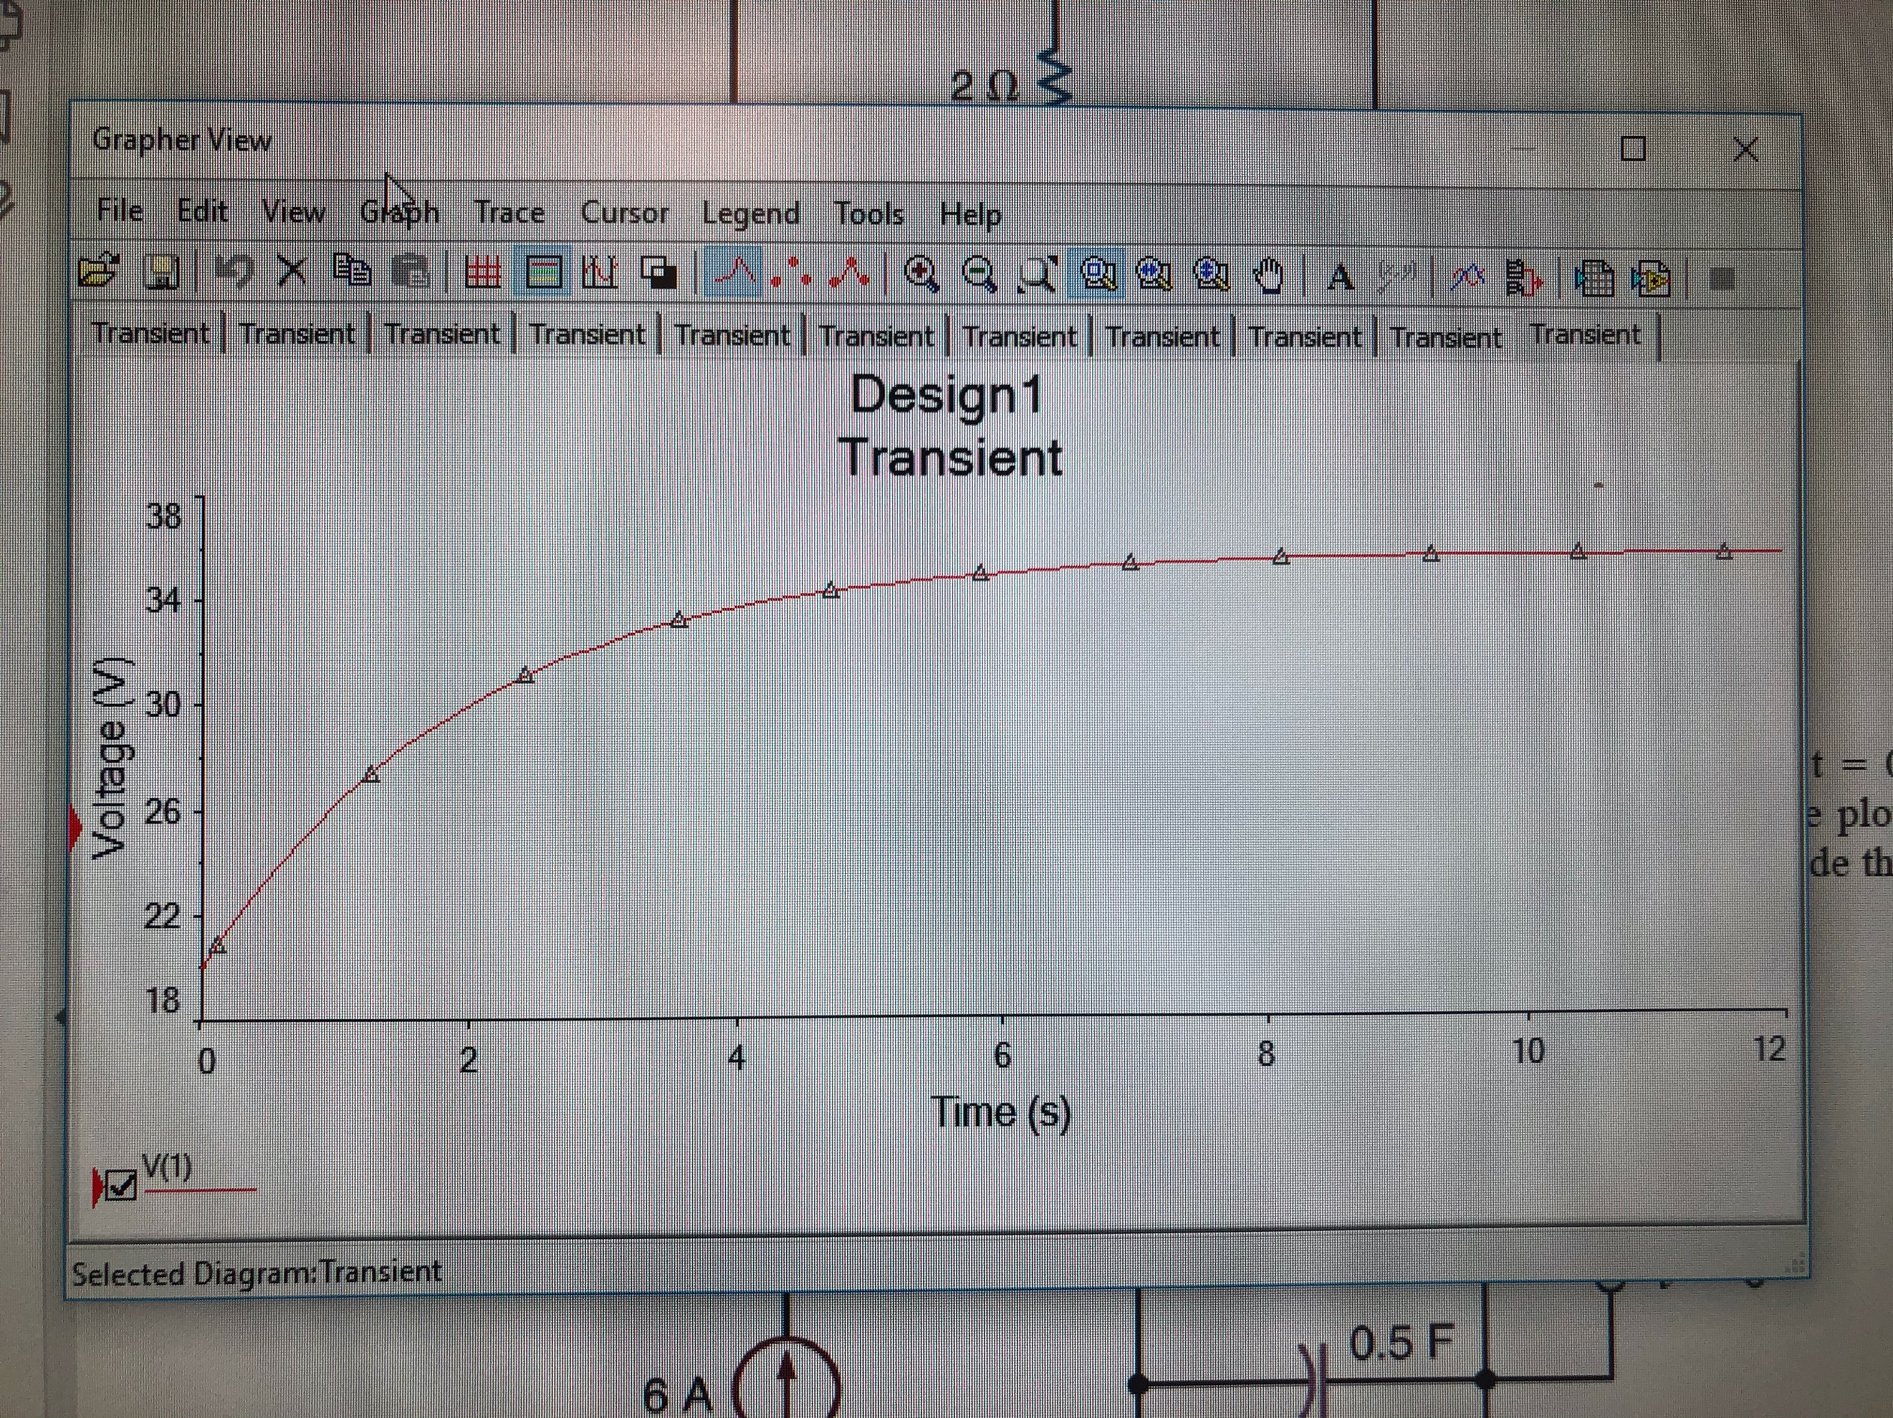

Graph in MultiSim for exercise 4

Summary Table

|  |  |
| --- | --- |
| K1 | 12.0mA |
| K2 (K1+K2=-20.0) | -32.0mA |
| Tau | 2.0 |
| -1/Tau | 0.5 (or ½) |
| Vo(t) | 12-32e^-t/2 (V) |